
Brian L. Little
Diving Deeper into the Z80
An adventure of discovery of how the Z80 functions using logic simulation
Brian L. Little

Table of Contents
Introduction 3
The Adventure Begins 4
Thanks for the memories, the Registers 6
Register Latch 9
Where the action is, the ALU (Arithmetic Logic Unit) 10
ALU Slice 12
PLA (Programmable Logic Array) 13
Control 14
Putting it all together 15
Making it run 16
A quick dip into FPGA 17
Making it real on a DE0-Nano 18
Making it real on the DE10-Light 19

Introduction
The first computer I had the Timex Sinclair 1000, the US variant of the ZX81, which had a Z80 CPU. I quickly found out that I could bypass the limitations of Basic by using assembly language. The only limits now were the hardware. Since I learned 6502 assembly in college I quickly picked up on the Z80 assembly. I spent many hours pushing the limits of the Timex Sinclair 1000.
A few years later when I moved onto the PC I was hired as an electrical engineer for a company that made its own Z80 based computer used in quality control for the plastic molding industry. Working with the code rekindled my interest in the Z80. By that time my Timex Sinclair 1000 was long gone but the PC was more than capable of emulating it so I could once again enjoy coding Z80 assembly on the Timex Sinclair 1000.
Around 2010 I was introduced to FPGAs (Field Programmable Gate Arrays). The ability to construct hardware using Hardware Defined Language was intriguing. When I found out that you could also use logic symbols and simulate 74 series TTL chips it made me flash back to the days when I found the article for the Elf 1802 computer. I couldn’t afford the 1802 on my lawn mowing profits of my neighbors but my room was littered with logic diagrams for expansion of the long sought after Elf II. I had to get a FPGA development board.
My first project was adapting a ZX81 written in VHDL to my new board. I felt triumphant when I finally got the flashing K in the corner of the screen and was able to play Mazogs on it. After that the next step was to actually design a cpu from scratch, either the 1802 or the Z80. That is where things ended. I didn’t have much time to devote to it so from time to time I dabbled with my FPGA over the years, not accomplishing much. I even got another FPGA board with more bells and whistles to motivate me, which didn’t work.
Over the last few years through the internet I found sites that had high resolution pictures of the Z80 substrate. Sites that reversed engineered the substrate into schematics and used them to make a Z80 on the FPGA. I also found a net level Z80 simulator and a digital simulator that could analyze a circuit and export hdl code. This sparked my interest again.
One thing I found lacking is more detailed explanation of the logic inside the Z80. So I am writing this to document what I found in my adventure.
So now armed with these resources we are ready to start our adventure by taking the deep dive into the Z80.

The Adventure Begins
The purpose of this book is to take us on an adventure through the inner workings of the Zilog Z80 computer processing unit (cpu) henceforth will be mentioned as the Z80. We will analyze the logic that makes up the Z80. All code related to this guide can be found on GitHub at
Diving Deeper into the Z80
Luckily for us there have been ardent adventurers that have blazed the trail before us. We give great thanks for this as this makes our travels easier. These adventurers are as follows;
- Visual6502.
  - Z80 Die shots
  - This site is hosted by a group that has decapped the Z80 and made high resolution shots of the dies which others have used for reverse engineering of the logic. It might be worth a look to see the other cpus and peripherals they have made die shots for.
- Ken Shirriff's blog
  - Index
  - Z80 Notes A collection of technical notes that Ken has written about the inner workings and specifications of the Z80
  - Ken reverse engineers critical parts of the Z80 dies. He explains in detail the logic of the parts listed above. He has also reverse engineered various other cpus and shares their highlights as well.
- Baltazar Studios
  - Baltazar Studio
  - Goran Devic hosts this site and he has many articles where he has reversed engineer the Z80. The site mentions his Github site that has the A-Z80 a FPGA soft core made up of the logic he reversed engineered from the die. He has broken down the logic into the schematics that we use in this book. He also has coded a Z80 simulator, the Z80 Explorer, that is a netlist simulator. You can watch the die in action and drill into the logic of any part of the die.
Now any adventurer is only as good as his skills and to go on this adventure you should have a basic understanding of digital logic, reading schematics and optionally FPGAs.

We must equip ourselves for the adventure ahead so these items must be added to or gear bag.
- Digital
  - Digital on GitHub
  - This will be our go to tool to delve into the mysteries of the Z80. You can find the code for the logic diagrams shown in this guide on my GitHub page. This tool will let you simulate the logic flow in the logic diagram, generate truth tables, run test scripts, generate Verilog code with test bench script and VHDL code with test bench script. Their are other options as well for deeper understanding of the logic diagrams.
- Z80 Explorer
  - Z80 Explorer on GitHub
  - This is an optional item but well worth having if you want to dive into the depths of the Z80. This is a netlist simulator that will run assembly and highlight the areas of the die that is being used. You can also get a netlist diagram of the logic for any selected section.
- Z80 Assembler/Debugger
  - TBD
Our itinerary for our journey will take us first through the fundamental parts of the Z80. The Arithmetic Logic Unit (ALU), Registers, Programmable Logic Array (PLA) and Control Logic sections will be covered in their own sections. We will then construct a simple Z80 based computer in Digital and make a simple operating system. For the truly adventurous we will take the generated Verilog and VHDL code to program a DE0-Nano and DE10-Lite FPGA development board.

Thanks for the memories, the Registers
The first stop in our adventure is the registers. The registers are the scratch pad of the Z80 retaining data for the ALU to use, program flow and indexing. These registers are made up of latches which are sequential logic.
A sequential digital circuit is a logic circuit that is dependent on the previous values of inputs and is usually triggered by a clock signal. Latches, multiplexers, and flip flops are examples of sequential logic.

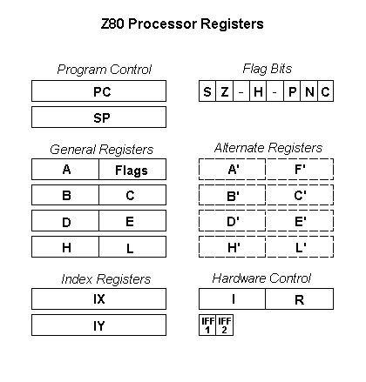
These registers are either 8 or 16 bit and are general or for specialized purposes as shown below.

General
These are 8 bit registers that are paired together as AF, BC, DE and HL. There are also the alternate registers to these registers which can be switched back and forth from general to alternate.
The AF register register also has the purpose of being the accumulator and flags used in ALU processes. When an instruction requires data directly from memory the data is put into the accumulator first before doing the operation. Then the result of the operation is then placed back into the accumulator. The F or flag register holds flags set by the operation in the ALU. These flags are;
- S – Set for the use of 2s complement math which is used to make the add function do subtraction.
- Z – Zero - Set if the accumulator has a zero value
- H – Half Carry- Takes the 3rd bit bit value and moves it to the 4th bit in the accumulator. See the next section on the ALU.
- P – Parity – Set if the accumulator has an even number of set bits. If the 2s complement produces a carry it sets this bit
- N – Negate – Set if the previous operation was subtraction (2s complement)
- C – Carry – Set if the adding process in the ALU produces a carry
There are a few instructions that let you handle the flags as an 8 bit register.
2s Complement is done by inverting the second operand then adding it to the first operand then adding the s flag then putting the carry in the p flag. For example
10 – 8 =2
1010 (10)
+ 0111 (8 inverted)
+ 0001 (S flag)
= 0010 (2)

The b register is used as a decrementing counter for looping that continues until a it goes to zero.
The BC, DE, and HL registers can be used as 8 bit registers if separated as B, C, D, E, H and L or as 16 bit registers BC, DE and HL.

Program Flow
The PC (Program Counter) is a 16 bit register that holds the pointer for the next instruction in memory to be processed. One the operation is completed it increments the correct number of bytes for that operation. The PC can be altered by a jump or branch command. The call command puts the PC on the stack (see below) then puts the address in the call command. Once the return command is encountered the PC pulls from the stack so it can resume its operations. This process is used in interrupts.

The SP (Stack Pointer) is a 16 bit register that uses memory as a storage space. The LD SP command can load the start of the stack with a memory address. It decrements from that since it is a first in first out (fifo) stack. It can be used to preserve a 16 bit register (i.e. DE) before a call. Interrupts cause the PC and general register pairs to be pushed (placed) on the stack then popped (taken) from the stack when the interrupt is finished This preserves the state of the CPU to when an interrupt occurs.

Index Registers
The registers IX and IY are 16 bit registers. They hold a base address that a positive or negative index is added to the index can be incremented or decremented. This allows quick indexing of data tables.

Hardware Control
The I and R registers are 8 bit registers used in hardware control. The I register holds the upper 8 bits of an interrupt routine while the device doing the interrupting provides the lower 8 bit. This allows dynamic mapping of interrupts in memory.
The R register is the memory refresh register. This is used for dynamic ram that requires refreshing. It is used for the lower 8 bits of addressing. After each hardware refresh the lower 7 bits are incremented while the 8th bit remains the same and can be set with the LD R, A command. An interesting use of this register is in the ZX81 computer. The R register is used as in getting the bitmaps for the characters mapped in ROM.
The IFF 1 and 2 bits are interrupt flags. IFF1 when set can disable some interrupts. So when an interrupt occurs IFF1 is copied into IFF2. Then IFF1 is set to disable any other interrupts. After the interrupt is finished IFF2 is copied back into IFF1.
Now we will dive deeper into the logic of the registers and its control circuitry.

Register Latch
The register latch is simple a D type flip flop with the clock tied to a tristate buffer which is driven by the we (write enable) input. Although the diagram below show db (data bus) as an 8 bit output it is bidirectional. The tristate buffer driven high by oe it allows Q (output) to appear on db. When oe is driven low the data present at db is sent to d (input).

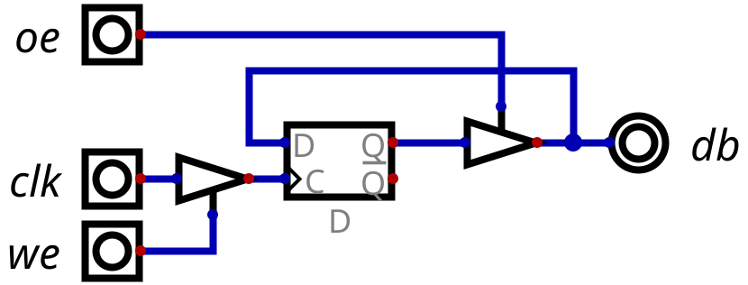
When we is high it enables the clock. When oe is low and clk goes high the data at db is loaded in the flip flop. At the next clk transition to high it will put the data on Q and if oe is set to high the data is passed to db. Then if we is set low it will retain the data acting as a latch since the tristate buffer blocks the clock input.

Where the action is, the ALU (Arithmetic Logic Unit)
The next stop in our adventure is the heart of the Z80, the ALU. This is where all the action is.
Wikipeada states:
An arithmetic logic unit (ALU) is a combinational digital circuit that performs arithmetic and bitwise operations on integer binary numbers.
A combinational digital circuit is a logic circuit that is not dependent on a clock signal to function. The results instantaneously change with changes from the inputs.

One very interesting fact is even though the Z80 is an eight bit CPU, the ALU is only four bits. This means each of the functions of the ALU must first be performed on the lower 4 bits then on the upper 4 bits.

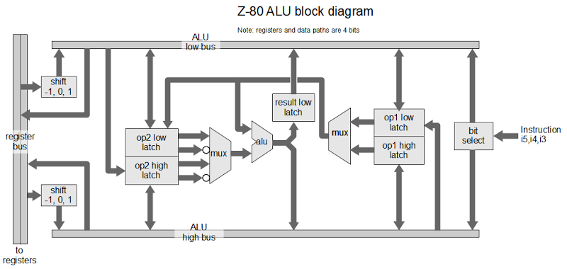
You will notice the alu appears in the center of the diagram with support logic around it. This is because the ALU only adds, ands, ors and xors the two operands. All other functions are handled by other logic blocks.
On the left is the register bus. This bus allows the registers to directly access the ALU. The memory can also access the ALU high and low busses. One of the flags in the flag register, the Half Carry, is used in the ALU in adding to hold the carry status from the low four bit add into the high 4 bit add. Then from the register bus it goes through the shift logic. This will do a shift left one bit, right one bit or none before placing it on the high and low ALU busses. So as the data from the registers gets loaded it is shifted as needed as well.
Once the data is loaded on the ALU busses it is accessible to the op1 and op2 high and low latches. You will noticed the ALU high bus can load the op1 low latch and the ALU low bus can load the op2 high latch. This enables 4 bit binary coded dec1mial (BCD) shifts RRD and RLD.
The muxes are multiplexers that allow the switching from low 4 bit to high4 bit latches since the alu only performs 4 bit functions. Because of this, a result low latch needs to latch the results onto the ALU low bus so once the high bits result is is placed on the ALU high bus all 8 bits are available. The op2 mux also permits the data of the op2 latch to be inverted. This permits subtraction by using 2s complement addition.
Finally the result can have each individual bit of the 8 bits to be set or cleared. The bits 3, 4, and 5 of the instruction byte designate which bit to perform the operation on.
The operation of the ALU follows the sequence below for the Add A, B command

ALU Slice

PLA (Programmable Logic Array)

Control

Putting it all together

Making it run

A quick dip into FPGA

Making it real on a DE0-Nano

Making it real on the DE10-Light

